Project Design Phase – II
Data Flow Diagram (DFD) & User Stories
Date: | 23-12-2025
Team ID:
Project Name: | Bookstore
Maximum Marks: | 4 Marks

Data Flow Diagrams (DFD)
A Data Flow Diagram (DFD) illustrates how data moves within the Bookstore platform. It represents how users (buyers), sellers, and admin interact with the system, how data flows between frontend and backend services, and how information is stored in the database.
Key Entities
- User (Book Buyer)
- Seller
- Admin
- Bookstore System
- Database
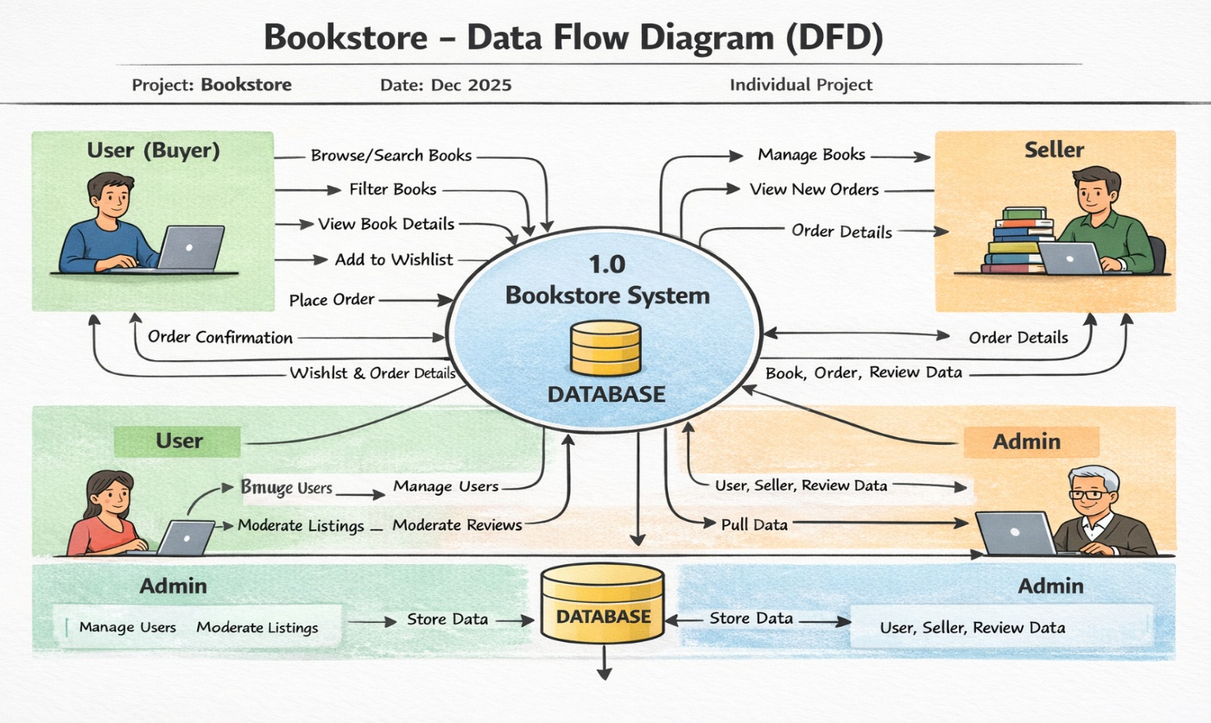
Data Flow Description
- Users browse books, search, filter, review, add to wishlist, and place orders.
- Sellers add, update, and manage book listings and view orders.
- Admin manages users, sellers, books, and platform moderation.
- All actions interact with the database for storage and retrieval.

User Stories
User Story Table – Bookstore
User Type | Functional Requirement (Epic) | User Story / Task | Acceptance Criteria | Priority | Release
User (Buyer) | Book Browsing | As a user, I can browse all available books. | Books are displayed with title, author, price, and rating. | High | Sprint-1
User (Buyer) | Search & Filter | As a user, I can search and filter books by category, price, and rating. | Relevant books are displayed based on filters. | High | Sprint-1
User (Buyer) | Book Details | As a user, I can view detailed information of a book. | Book detail page shows description, reviews, and seller info. | High | Sprint-1
User (Buyer) | Wishlist | As a user, I can add books to my wishlist. | Book appears in wishlist page. | Medium | Sprint-2
User (Buyer) | Order Placement | As a user, I can place an order for a book. | Order is created and visible in my orders list. | High | Sprint-1
User (Buyer) | Review System | As a user, I can give ratings and reviews after purchase. | Review appears on the book page. | Medium | Sprint-2
Seller | Book Management | As a seller, I can add new books for sale. | Book appears in product listing. | High | Sprint-1
Seller | Inventory Management | As a seller, I can update price and stock of my books. | Changes reflect immediately. | High | Sprint-2
Seller | Order Management | As a seller, I can view orders placed for my books. | Orders list updates correctly. | Medium | Sprint-2
Admin | User Management | As an admin, I can manage users and sellers. | Users can be viewed, blocked, or removed. | High | Sprint-1
Admin | Book Moderation | As an admin, I can approve or remove book listings. | Platform content remains valid and safe. | High | Sprint-1
Admin | Review Monitoring | As an admin, I can monitor reviews and ratings. | Inappropriate reviews can be removed. | Medium | Sprint-2

